Additional File 1

Temporal resource partitioning in reef sharks confirmed through gap analysis of acoustic tracking data

Michael J. Williamson*, Emma J. Tebbs, Terence P. Dawson, David J. Curnick, Francesco Ferretti, Aaron B. Carlisle, Taylor K. Chapple, Robert J. Schallert, David M. Tickler, Barbara A. Block and David M. P. Jacoby

* Corresponding author: Michael J. Williamson; E-mail: michael.williamson@kcl.ac.uk

This supplementary material contains:
Figure S1. Histogram of inter-receiver distances in the BIOT MPA

Figure S2. Map of Egmont reef with receiver locations indicated with red dots and a 500m metre buffer of the estimated receiving range around each receiver.

Figure S3. Map of Peros Banos reef with receiver locations indicated with red dots and a 500m metre buffer of the estimated receiving range around each receiver.

Figure S4. Map of Saloman with receiver locations indicated with red dots and a 500m metre buffer of the estimated receiving range around each receiver.

Figure S5. Plots of model residuals to check for homoscedasticity and autocorrelation.

Table S1. Metadata for tagged individuals analysed from 2014 to 2018.

Table S2. Outputs from collinearity tests using ‘check_collinearity’ function in the ‘performance’ package.

Table S3. Model selection table following the dredge on the global model.

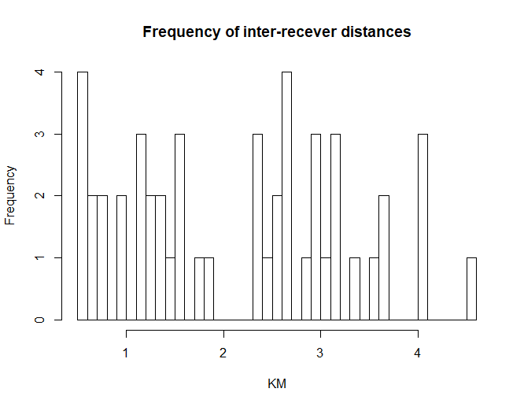

Figure S1 Histogram of inter-receiver distances in the BIOT MPA

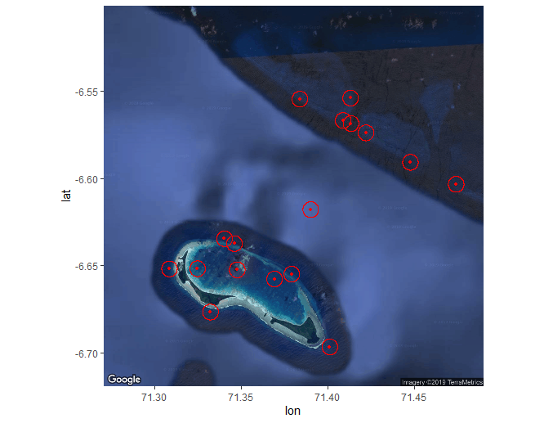
Figure S2 Map of Egmont reef with receiver locations indicated with red dots and a 500m metre buffer of the estimated receiving range around each receiver.

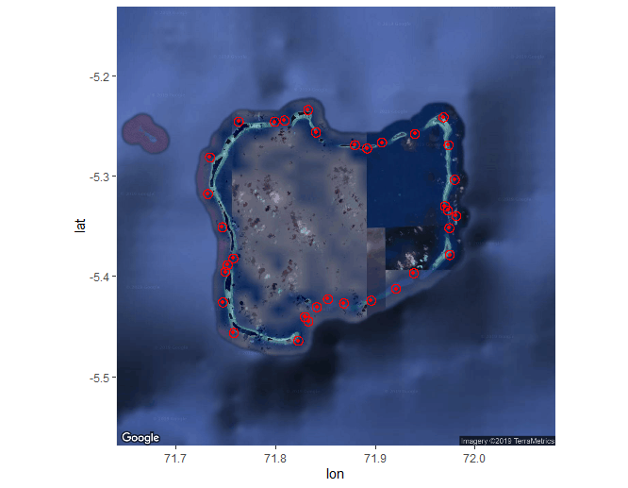
Figure S3 Map of Peros Banos reef with receiver locations indicated with red dots and a 500m metre buffer of the estimated receiving range around each receiver.

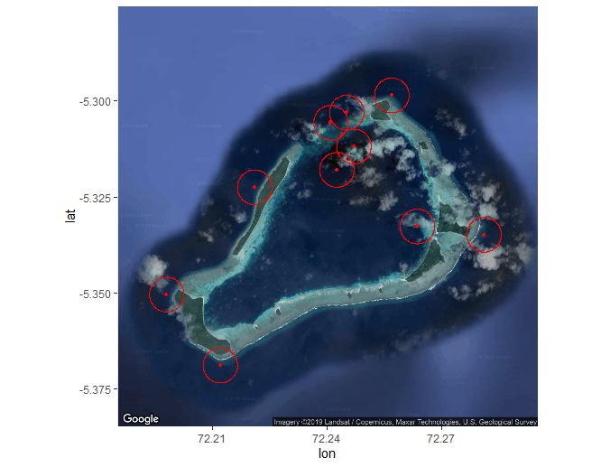

Figure S4 Map of Saloman reef with receiver locations indicated with red dots and a 500m metre buffer of the estimated receiving range around each receiver.
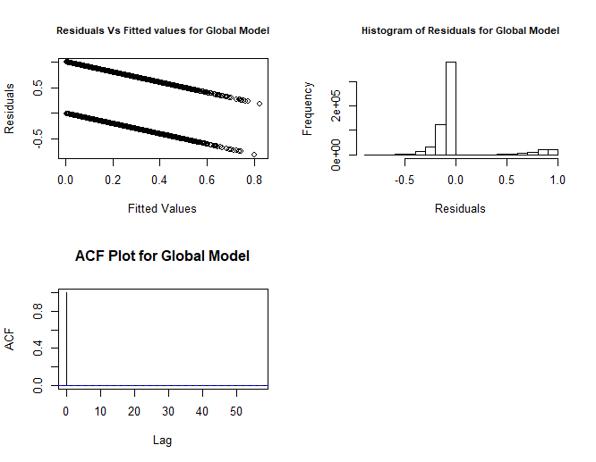
Figure S5 Plots of global model residuals to check for heteroscedasticity, autocorrelation and errors checked for binomial distribution. Binomial distribution of residual vs fitted and histogram of residuals indicate lack of homoscedasticity and a binomial distribution. ACF values indicate no autocorrelation.

Table S1. Metadata for tagged individuals analysed from 2014 to 2018. First detection, last detection, detection duration (in days), sex and size (when tagged), and tagging date are included.

ID | Species | Sex | Length | Tag date | First detection | Final detection | Detection duration (days)
2388 | Silvertip Shark | F | 112 | 16/04/2016 | 18/06/2016 | 20/09/2017 | 459
2390 | Grey Reef Shark | M | 118 | 16/04/2016 | 24/04/2016 | 19/09/2016 | 148
12950 | Silvertip Shark | F | 119 | 25/03/2014 | 01/04/2014 | 03/12/2014 | 246
12952 | Silvertip Shark | M | 97 | 29/03/2014 | 29/03/2014 | 09/12/2014 | 255
12954 | Silvertip Shark | F | 121 | 29/03/2014 | 29/03/2014 | 29/03/2014 | 0
12956 | Silvertip Shark | F | 150 | 27/03/2014 | 27/04/2014 | 17/06/2014 | 51
12958 | Silvertip Shark | F | 114 | 27/03/2014 | 03/04/2014 | 03/12/2014 | 244
12962 | Silvertip Shark | M | 127 | 25/03/2014 | 26/03/2014 | 22/12/2018 | 1732
12964 | Silvertip Shark | F | 104 | 25/03/2014 | 27/03/2014 | 26/11/2016 | 975
12966 | Silvertip Shark | M | 117 | 25/03/2014 | 29/03/2014 | 02/11/2018 | 1679
12968 | Silvertip Shark | M | 115 | 29/03/2014 | 29/03/2014 | 05/12/2014 | 251
13575 | Grey Reef Shark | F | 94 | 22/03/2013 | 01/01/2014 | 20/03/2018 | 1539
13576 | Grey Reef Shark | F | 100 | 22/03/2013 | 01/01/2014 | 10/12/2014 | 343
13577 | Silvertip Shark | M | 119 | 17/03/2013 | 01/01/2014 | 22/01/2017 | 1117
19318 | Grey Reef Shark | F | 110 | 22/03/2013 | 09/07/2014 | 13/07/2014 | 4
19506 | Grey Reef Shark | M | 122 | 18/03/2018 | 19/04/2018 | 14/11/2018 | 209
19514 | Grey Reef Shark | M | 70 | 14/03/2018 | 19/03/2018 | 31/12/2018 | 287
19516 | Grey Reef Shark | M | 119 | 16/03/2018 | 21/03/2018 | 31/12/2018 | 285
19517 | Silvertip Shark | F | 129 | 12/04/2016 | 21/12/2016 | 21/12/2016 | 0
19518 | Grey Reef Shark | F | 125 | 16/03/2018 | 16/03/2018 | 31/12/2018 | 290
19520 | Grey Reef Shark | F | 121 | 19/03/2018 | 04/07/2018 | 24/09/2018 | 82
19523 | Silvertip Shark | M | 137 | 16/04/2016 | 26/04/2016 | 18/12/2018 | 966
19524 | Grey Reef Shark | F | 143 | 16/04/2016 | 17/04/2016 | 11/12/2017 | 603
25534 | Silvertip Shark | F | 113 | 20/03/2014 | 28/03/2014 | 06/04/2016 | 740
25535 | Silvertip Shark | M | 108 | 20/03/2014 | 30/03/2014 | 27/04/2014 | 28
25536 | Silvertip Shark | M | 128 | 22/03/2014 | 02/04/2014 | 05/12/2014 | 247
25537 | Grey Reef Shark | F | 88 | 20/03/2014 | 21/01/2015 | 31/07/2016 | 557
25539 | Silvertip Shark | M | 104 | 22/03/2014 | 29/03/2014 | 14/08/2018 | 1599
25540 | Grey Reef Shark | F | 137 | 22/03/2014 | 01/04/2014 | 11/04/2014 | 10
25541 | Grey Reef Shark | F | 106 | 22/03/2014 | 30/03/2014 | 13/09/2016 | 898
25542 | Silvertip Shark | F | 115 | 25/03/2014 | 02/04/2014 | 06/12/2014 | 248
25543 | Grey Reef Shark | F | 140 | 22/03/2014 | 29/03/2014 | 28/03/2017 | 1095
25544 | Silvertip Shark | M | 134 | 24/03/2014 | 27/03/2014 | 01/12/2014 | 249
25545 | Silvertip Shark | F | 108 | 24/03/2014 | 29/03/2014 | 30/09/2017 | 1281
25546 | Grey Reef Shark | M | 125 | 23/03/2014 | 15/04/2014 | 03/08/2016 | 841
25547 | Silvertip Shark | F | 118 | 24/03/2014 | 30/03/2014 | 15/07/2014 | 107
25548 | Silvertip Shark | F | 117 | 25/03/2014 | 27/03/2014 | 10/04/2016 | 745
25549 | Grey Reef Shark | M | 116 | 23/03/2014 | 30/04/2014 | 25/06/2016 | 787
25550 | Silvertip Shark | F | 122 | 24/03/2014 | 30/03/2014 | 18/05/2014 | 49
25552 | Grey Reef Shark | F | 140 | 25/03/2014 | 27/03/2014 | 02/12/2014 | 250
25553 | Grey Reef Shark | M | 131 | 24/03/2014 | 26/03/2014 | 08/07/2016 | 835
27584 | Silvertip Shark | F | 108 | 17/03/2013 | 11/01/2014 | 03/12/2014 | 326
27595 | Grey Reef Shark | F | 97 | 09/02/2013 | 21/05/2016 | 21/05/2016 | 0
27596 | Grey Reef Shark | F | 114 | 09/02/2013 | 24/04/2014 | 01/06/2014 | 38
27598 | Silvertip Shark | M | 115 | 13/03/2013 | 05/01/2014 | 10/02/2014 | 36
27603 | Silvertip Shark | M | 119 | 12/03/2013 | 06/01/2014 | 07/12/2014 | 335
27605 | Grey Reef Shark | F | 100 | 16/03/2013 | 20/01/2014 | 12/02/2014 | 23
27606 | Silvertip Shark | F | 107 | 13/03/2013 | 22/01/2014 | 20/02/2014 | 29
27609 | Silvertip Shark | F | 116 | 12/03/2013 | 01/01/2014 | 27/01/2014 | 26
27611 | Silvertip Shark | F | 115 | 09/02/2013 | 01/01/2014 | 10/12/2014 | 343
28608 | Grey Reef Shark | F | 140 | 18/03/2018 | 15/06/2018 | 12/12/2018 | 180
28611 | Grey Reef Shark | F | 155 | 18/03/2018 | 20/03/2018 | 31/12/2018 | 286
28612 | Grey Reef Shark | F | 115 | 13/03/2018 | 13/03/2018 | 16/10/2018 | 217
28618 | Grey Reef Shark | M | 74 | 13/03/2018 | 15/03/2018 | 30/11/2018 | 260
28624 | Silvertip Shark | F | 110 | 12/03/2018 | 27/11/2018 | 27/11/2018 | 0
28625 | Grey Reef Shark | F | 107 | 11/03/2018 | 12/03/2018 | 29/10/2018 | 231
28627 | Silvertip Shark | F | 117 | 12/03/2018 | 07/05/2018 | 07/08/2018 | 92
28628 | Grey Reef Shark | F | 115 | 11/03/2018 | 21/03/2018 | 23/09/2018 | 186
28629 | Grey Reef Shark | M | 113 | 11/03/2018 | 13/03/2018 | 29/12/2018 | 291
28631 | Grey Reef Shark | M | 121 | 11/03/2018 | 12/03/2018 | 09/12/2018 | 272
28632 | Grey Reef Shark | F | 116 | 11/03/2018 | 12/05/2018 | 29/12/2018 | 231
28633 | Grey Reef Shark | F | 82 | 13/03/2018 | 17/03/2018 | 28/10/2018 | 225
28637 | Silvertip Shark | M | 124 | 12/03/2018 | 29/04/2018 | 04/08/2018 | 97
28638 | Grey Reef Shark | F | 86 | 11/03/2018 | 04/11/2018 | 31/12/2018 | 57
28639 | Silvertip Shark | F | 94 | 12/03/2018 | 18/04/2018 | 06/06/2018 | 49
28641 | Grey Reef Shark | M | 95 | 11/03/2018 | 12/03/2018 | 21/12/2018 | 284
28642 | Silvertip Shark | M | 103 | 13/03/2018 | 13/03/2018 | 10/10/2018 | 211
28644 | Grey Reef Shark | F | 132 | 18/03/2018 | 01/04/2018 | 20/04/2018 | 19
28660 | Silvertip Shark | F | 125 | 19/03/2018 | 21/03/2018 | 10/11/2018 | 234
28662 | Grey Reef Shark | F | 133 | 19/03/2018 | 20/03/2018 | 29/12/2018 | 284
28670 | Silvertip Shark | M | 125 | 19/03/2018 | 23/03/2018 | 29/12/2018 | 281
28672 | Grey Reef Shark | M | 112 | 19/03/2018 | 20/03/2018 | 31/12/2018 | 286
28674 | Grey Reef Shark | F | 123 | 19/03/2018 | 20/03/2018 | 31/12/2018 | 286
34176 | Silvertip Shark | F | 140 | 22/03/2013 | 07/01/2014 | 21/11/2014 | 318
34177 | Silvertip Shark | M | 115 | 22/03/2013 | 01/01/2014 | 08/12/2014 | 341
34178 | Silvertip Shark | F | 102 | 22/03/2013 | 27/07/2014 | 27/07/2014 | 0
34179 | Silvertip Shark | F | 99.5 | 17/03/2013 | 04/01/2014 | 03/03/2014 | 58
52975 | Silvertip Shark | M | 123 | 22/03/2013 | 02/01/2014 | 02/12/2014 | 334
54815 | Grey Reef Shark | F | 118 | 01/04/2016 | 01/04/2016 | 08/04/2018 | 737
54817 | Silvertip Shark | F | 134 | 01/04/2016 | 04/04/2016 | 24/04/2016 | 20
54821 | Silvertip Shark | F | 146 | 01/04/2016 | 04/04/2016 | 05/04/2016 | 1
54822 | Silvertip Shark | F | 135 | 01/04/2016 | 28/04/2016 | 14/10/2016 | 169
54825 | Silvertip Shark | F | 138.5 | 01/04/2016 | 06/04/2016 | 06/04/2016 | 0
54845 | Silvertip Shark | F | 151 | 12/04/2016 | 26/09/2016 | 01/10/2016 | 5
54846 | Grey Reef Shark | F | 135 | 08/04/2016 | 09/04/2016 | 31/12/2018 | 996
54849 | Silvertip Shark | M | 137 | 08/04/2016 | 10/04/2016 | 22/12/2018 | 986
54851 | Grey Reef Shark | F | 171 | 10/04/2016 | 07/06/2016 | 09/06/2018 | 732
54852 | Grey Reef Shark | M | 114 | 08/04/2016 | 09/04/2016 | 31/12/2018 | 996
54858 | Silvertip Shark | M | 112 | 10/04/2016 | 11/05/2016 | 14/06/2016 | 34
54860 | Grey Reef Shark | F | 136 | 07/04/2016 | 07/04/2016 | 27/04/2016 | 20
54863 | Grey Reef Shark | F | 156 | 08/04/2016 | 09/04/2016 | 09/04/2016 | 0
54864 | Grey Reef Shark | F | 120 | 10/04/2016 | 10/04/2016 | 28/11/2018 | 962
54866 | Grey Reef Shark | F | 141 | 08/04/2016 | 28/04/2016 | 31/12/2018 | 977
54868 | Grey Reef Shark | M | 106 | 08/04/2016 | 22/03/2018 | 19/04/2018 | 28
54869 | Grey Reef Shark | F | 127 | 10/04/2016 | 29/04/2016 | 13/04/2017 | 349
54872 | Grey Reef Shark | F | 118 | 10/04/2016 | 11/04/2016 | 13/07/2016 | 93
54874 | Grey Reef Shark | F | 97 | 10/04/2016 | 25/04/2016 | 14/06/2016 | 50
54877 | Grey Reef Shark | F | 143 | 08/04/2016 | 18/05/2016 | 02/11/2016 | 168
54880 | Silvertip Shark | F | 87 | 15/04/2016 | 26/04/2016 | 30/12/2018 | 978
54882 | Grey Reef Shark | M | 134 | 15/04/2016 | 20/04/2016 | 30/08/2016 | 132
54883 | Grey Reef Shark | F | 100 | 15/04/2016 | 12/06/2016 | 30/08/2018 | 809
54884 | Grey Reef Shark | F | 155 | 16/04/2016 | 20/04/2016 | 01/09/2016 | 134
54886 | Grey Reef Shark | F | 137 | 15/04/2016 | 19/04/2016 | 11/01/2018 | 632
54887 | Silvertip Shark | F | 161 | 16/04/2016 | 17/04/2016 | 28/11/2017 | 590
54889 | Silvertip Shark | F | 88 | 15/04/2016 | 21/04/2016 | 31/12/2018 | 984
54890 | Grey Reef Shark | M | 136 | 16/04/2016 | 16/04/2016 | 23/04/2018 | 737
54892 | Grey Reef Shark | F | 132 | 15/04/2016 | 17/06/2016 | 01/11/2017 | 502
54893 | Silvertip Shark | F | 162 | 15/04/2016 | 18/04/2016 | 29/10/2018 | 924
54895 | Grey Reef Shark | M | 106 | 15/04/2016 | 15/04/2016 | 14/12/2018 | 973
54896 | Grey Reef Shark | F | 157 | 15/04/2016 | 21/08/2016 | 09/12/2017 | 475
54898 | Silvertip Shark | M | 151 | 12/04/2016 | 10/10/2016 | 29/12/2018 | 810
54899 | Silvertip Shark | M | 203 | 14/04/2016 | 16/04/2016 | 27/10/2017 | 559
54901 | Grey Reef Shark | F | 152 | 14/04/2016 | 17/05/2016 | 09/10/2018 | 875
54904 | Grey Reef Shark | F | 122 | 14/04/2016 | 18/04/2016 | 16/09/2018 | 881
54905 | Silvertip Shark | F | 120 | 14/04/2016 | 22/04/2016 | 22/06/2016 | 61
54911 | Silvertip Shark | F | 104 | 14/04/2016 | 19/07/2016 | 11/12/2018 | 875
54912 | Silvertip Shark | M | 196 | 15/04/2016 | 29/05/2016 | 04/06/2018 | 736
54914 | Grey Reef Shark | F | 117 | 16/04/2016 | 25/04/2016 | 31/12/2018 | 980
54915 | Silvertip Shark | F | 139 | 16/04/2016 | 18/04/2016 | 18/12/2018 | 974
54919 | Grey Reef Shark | F | 118 | 14/03/2018 | 20/03/2018 | 31/12/2018 | 286
54920 | Grey Reef Shark | M | 138 | 18/03/2018 | 05/04/2018 | 24/12/2018 | 263
54922 | Grey Reef Shark | F | 132 | 14/03/2018 | 24/03/2018 | 31/12/2018 | 282
54925 | Grey Reef Shark | F | 135 | 14/03/2018 | 19/03/2018 | 31/12/2018 | 287
54927 | Grey Reef Shark | F | 86 | 16/03/2018 | 17/03/2018 | 31/12/2018 | 289
54929 | Grey Reef Shark | F | 108 | 16/03/2018 | 05/10/2018 | 05/10/2018 | 0
54931 | Grey Reef Shark | M | 121 | 15/04/2016 | 18/04/2016 | 31/12/2018 | 987
54932 | Grey Reef Shark | M | 135 | 14/03/2018 | 19/03/2018 | 31/12/2018 | 287
54933 | Silvertip Shark | F | 148 | 14/04/2016 | 15/04/2016 | 26/12/2018 | 985
54938 | Grey Reef Shark | F | 148 | 14/03/2018 | 26/03/2018 | 31/12/2018 | 280
54947 | Silvertip Shark | F | 144 | 14/04/2016 | 27/04/2016 | 31/12/2018 | 978
54949 | Grey Reef Shark | M | 128 | 15/03/2018 | 29/03/2018 | 03/11/2018 | 219
54952 | Grey Reef Shark | F | 146 | 23/03/2016 | 23/03/2016 | 21/09/2018 | 912
54954 | Grey Reef Shark | F | 145 | 24/03/2016 | 06/04/2016 | 30/09/2018 | 907
54955 | Grey Reef Shark | F | 142 | 23/03/2016 | 28/03/2016 | 30/09/2018 | 916
54957 | Silvertip Shark | F | 93 | 24/03/2016 | 25/03/2016 | 26/09/2018 | 915
54958 | Grey Reef Shark | F | 138 | 23/03/2016 | 07/04/2016 | 25/12/2018 | 992
54959 | Grey Reef Shark | F | 104 | 23/03/2016 | 23/03/2016 | 29/09/2016 | 190
54961 | Silvertip Shark | M | 86 | 23/03/2016 | 25/03/2016 | 29/12/2018 | 1009
54962 | Grey Reef Shark | F | 117 | 24/03/2016 | 24/03/2016 | 22/10/2018 | 942
59950 | Grey Reef Shark | F | 110 | 22/03/2015 | 26/03/2015 | 20/09/2017 | 909
59951 | Silvertip Shark | M | 183 | 22/03/2015 | 17/04/2015 | 25/06/2016 | 435
59953 | Grey Reef Shark | M | 110 | 22/03/2015 | 12/03/2016 | 12/05/2017 | 426
59955 | Grey Reef Shark | M | 131 | 22/03/2015 | 03/05/2015 | 19/05/2015 | 16
59957 | Grey Reef Shark | F | 133 | 21/03/2015 | 06/04/2015 | 09/10/2018 | 1282
59958 | Grey Reef Shark | F | 141 | 21/03/2015 | 24/03/2015 | 11/12/2018 | 1358
59959 | Grey Reef Shark | F | 133 | 21/03/2015 | 01/05/2015 | 18/11/2017 | 932
59960 | Grey Reef Shark | F | 150 | 21/03/2015 | 17/06/2015 | 03/10/2015 | 108
59961 | Grey Reef Shark | F | 145 | 21/03/2015 | 08/04/2015 | 19/09/2018 | 1260
59962 | Grey Reef Shark | F | 136 | 21/03/2015 | 19/03/2015 | 13/09/2018 | 1274
59963 | Silvertip Shark | F | 120 | 19/03/2015 | 19/03/2015 | 28/12/2018 | 1380
59964 | Grey Reef Shark | F | 112 | 19/03/2015 | 19/03/2015 | 01/11/2017 | 958
59966 | Grey Reef Shark | F | 139 | 0019-03-15 | 27/03/2015 | 27/03/2015 | 0
59968 | Silvertip Shark | M | 178 | 22/03/2015 | 04/04/2015 | 03/02/2016 | 305
59969 | Grey Reef Shark | F | 105 | 23/03/2015 | 01/04/2015 | 14/01/2017 | 654
59970 | Grey Reef Shark | M | 125 | 23/03/2015 | 07/04/2015 | 14/10/2018 | 1286
59971 | Grey Reef Shark | F | 97 | 23/03/2015 | 23/03/2015 | 28/08/2017 | 889
59972 | Grey Reef Shark | F | 101 | 23/03/2015 | 23/03/2015 | 12/04/2016 | 386
59973 | Grey Reef Shark | F | 70 | 23/03/2015 | 10/04/2015 | 05/11/2017 | 940
59975 | Grey Reef Shark | F | 114 | 23/03/2015 | 25/03/2015 | 12/04/2016 | 384
59976 | Grey Reef Shark | M | 106 | 23/03/2015 | 27/03/2015 | 31/12/2018 | 1375
59978 | Silvertip Shark | F | 166 | 23/03/2015 | 23/04/2015 | 13/06/2016 | 417
59979 | Grey Reef Shark | F | 96 | 23/03/2015 | 14/04/2015 | 15/12/2018 | 1341
59980 | Grey Reef Shark | F | 73 | 24/03/2015 | 16/04/2015 | 18/07/2018 | 1189
59981 | Grey Reef Shark | M | 131 | 23/03/2015 | 25/03/2015 | 21/09/2016 | 546
59982 | Silvertip Shark | M | 109 | 25/03/2015 | 30/03/2015 | 03/12/2016 | 614
59984 | Silvertip Shark | M | 134 | 25/03/2015 | 10/04/2015 | 28/04/2017 | 749
59985 | Silvertip Shark | M | 123 | 25/03/2015 | 26/04/2015 | 26/04/2017 | 731
59986 | Silvertip Shark | F | 127 | 25/03/2015 | 26/03/2015 | 27/03/2017 | 732
59987 | Silvertip Shark | M | 181 | 25/03/2015 | 03/06/2015 | 14/04/2017 | 681
59988 | Grey Reef Shark | F | 112 | 27/03/2015 | 27/03/2015 | 05/12/2018 | 1349
59991 | Silvertip Shark | F | 132 | 28/03/2015 | 14/04/2015 | 30/12/2018 | 1356
59992 | Silvertip Shark | M | 131 | 27/03/2015 | 01/04/2015 | 14/04/2018 | 1109
59993 | Silvertip Shark | M | 157 | 27/03/2015 | 03/04/2015 | 31/12/2018 | 1368
59994 | Silvertip Shark | F | 153 | 27/03/2015 | 05/04/2015 | 03/04/2016 | 364
59995 | Silvertip Shark | F | 143 | 27/03/2015 | 03/04/2015 | 05/03/2016 | 337
59996 | Grey Reef Shark | F | 124 | 25/03/2015 | 29/03/2015 | 28/04/2017 | 761
59997 | Grey Reef Shark | F | 108 | 25/03/2015 | 21/11/2015 | 09/04/2017 | 505
59999 | Grey Reef Shark | F | 122 | 25/03/2015 | 26/03/2015 | 04/10/2018 | 1288

Table S2 Outputs from collinearity tests using ‘check_collinearity’ function in the performance package.

Predictor | VIF | SE_factor
species | 1.045629 | 1.022384
sex | 1.035868 | 1.017776
log (size) | 1.009483 | 1.00473
diel stage | 1.000081 | 1.000039
season | 1.000073 | 1.000036

Table S3 Model selection table following the dredge on the global model. Presence of a variable or interaction in a model indicated by the + symbol. Degrees of freedom (df), Akaike information criterion (AIC), ΔAIC and Akaike weights (ω) presented for each model.

Model | day night | size | season | sex | species | daynight: species | size: species | season: species | sex: species | df | logLik | AICc | delta | weight
54 | + | NA | + | NA | + | + | NA | NA | NA | 7 | -179034 | 358082.3 | 0.00 | 0.17
182 | + | NA | + | NA | + | + | NA | + | NA | 8 | -179034 | 358083.2 | 0.87 | 0.11
62 | + | NA | + | + | + | + | NA | NA | NA | 8 | -179034 | 358083.3 | 0.98 | 0.11
318 | + | NA | + | + | + | + | NA | NA | + | 9 | -179033 | 358083.6 | 1.30 | 0.09
190 | + | NA | + | + | + | + | NA | + | NA | 9 | -179033 | 358084.2 | 1.84 | 0.07
56 | + | -0.13 | + | NA | + | + | NA | NA | NA | 8 | -179034 | 358084.2 | 1.87 | 0.07
446 | + | NA | + | + | + | + | NA | + | + | 10 | -179032 | 358084.5 | 2.17 | 0.06
120 | + | -0.50 | + | NA | + | + | + | NA | NA | 9 | -179033 | 358085.0 | 2.64 | 0.05
184 | + | -0.13 | + | NA | + | + | NA | + | NA | 9 | -179034 | 358085.1 | 2.73 | 0.04
64 | + | -0.13 | + | + | + | + | NA | NA | NA | 9 | -179034 | 358085.2 | 2.85 | 0.04
320 | + | -0.08 | + | + | + | + | NA | NA | + | 10 | -179033 | 358085.6 | 3.26 | 0.03
248 | + | -0.50 | + | NA | + | + | + | + | NA | 10 | -179033 | 358085.8 | 3.52 | 0.03
192 | + | -0.13 | + | + | + | + | NA | + | NA | 10 | -179033 | 358086.0 | 3.71 | 0.03
128 | + | -0.46 | + | + | + | + | + | NA | NA | 10 | -179033 | 358086.2 | 3.87 | 0.03
448 | + | -0.08 | + | + | + | + | NA | + | + | 11 | -179032 | 358086.5 | 4.12 | 0.02
384 | + | -0.42 | + | + | + | + | + | NA | + | 11 | -179032 | 358086.5 | 4.21 | 0.02
256 | + | -0.46 | + | + | + | + | + | + | NA | 11 | -179033 | 358087.1 | 4.74 | 0.02
512 | + | -0.41 | + | + | + | + | + | + | + | 12 | -179032 | 358087.4 | 5.09 | 0.01
22 | + | NA | + | NA | + | NA | NA | NA | NA | 6 | -179043 | 358097.1 | 14.72 | 0.00
150 | + | NA | + | NA | + | NA | NA | + | NA | 7 | -179042 | 358098.0 | 15.65 | 0.00
30 | + | NA | + | + | + | NA | NA | NA | NA | 7 | -179042 | 358098.0 | 15.71 | 0.00
286 | + | NA | + | + | + | NA | NA | NA | + | 8 | -179041 | 358098.4 | 16.02 | 0.00
Model | day night | size | season | sex | species | daynight: species | size: species | season: species | sex: species | df | logLik | AICc | delta | weight
24 | + | -0.13 | + | NA | + | NA | NA | NA | NA | 7 | -179042 | 358098.9 | 16.59 | 0.00
158 | + | NA | + | + | + | NA | NA | + | NA | 8 | -179041 | 358099.0 | 16.63 | 0.00
414 | + | NA | + | + | + | NA | NA | + | + | 9 | -179041 | 358099.3 | 16.95 | 0.00
88 | + | -0.50 | + | NA | + | NA | + | NA | NA | 8 | -179042 | 358099.7 | 17.38 | 0.00
152 | + | -0.13 | + | NA | + | NA | NA | + | NA | 8 | -179042 | 358099.8 | 17.51 | 0.00
32 | + | -0.13 | + | + | + | NA | NA | NA | NA | 8 | -179042 | 358099.9 | 17.58 | 0.00
288 | + | -0.08 | + | + | + | NA | NA | NA | + | 9 | -179041 | 358100.3 | 17.98 | 0.00
216 | + | -0.50 | + | NA | + | NA | + | + | NA | 9 | -179041 | 358100.7 | 18.32 | 0.00
160 | + | -0.13 | + | + | + | NA | NA | + | NA | 9 | -179041 | 358100.8 | 18.50 | 0.00
96 | + | -0.46 | + | + | + | NA | + | NA | NA | 9 | -179041 | 358100.9 | 18.62 | 0.00
416 | + | -0.08 | + | + | + | NA | NA | + | + | 10 | -179041 | 358101.2 | 18.91 | 0.00
352 | + | -0.41 | + | + | + | NA | + | NA | + | 10 | -179041 | 358101.3 | 18.95 | 0.00
224 | + | -0.46 | + | + | + | NA | + | + | NA | 10 | -179041 | 358101.9 | 19.55 | 0.00
480 | + | -0.41 | + | + | + | NA | + | + | + | 11 | -179040 | 358102.2 | 19.89 | 0.00
14 | + | NA | + | + | NA | NA | NA | NA | NA | 6 | -179057 | 358126.0 | 43.66 | 0.00
6 | + | NA | + | NA | NA | NA | NA | NA | NA | 5 | -179059 | 358127.6 | 45.30 | 0.00
16 | + | 0.04 | + | + | NA | NA | NA | NA | NA | 7 | -179057 | 358128.0 | 45.65 | 0.00
8 | + | 0.06 | + | NA | NA | NA | NA | NA | NA | 6 | -179059 | 358129.6 | 47.28 | 0.00
50 | + | NA | NA | NA | + | + | NA | NA | NA | 6 | -179184 | 358380.2 | 297.87 | 0.00
58 | + | NA | NA | + | + | + | NA | NA | NA | 7 | -179184 | 358381.2 | 298.84 | 0.00
314 | + | NA | NA | + | + | + | NA | NA | + | 8 | -179183 | 358381.6 | 299.30 | 0.00
52 | + | -0.16 | NA | NA | + | + | NA | NA | NA | 7 | -179184 | 358382.0 | 299.67 | 0.00
116 | + | -0.52 | NA | NA | + | + | + | NA | NA | 8 | -179183 | 358382.8 | 300.50 | 0.00
60 | + | -0.16 | NA | + | + | + | NA | NA | NA | 8 | -179183 | 358383.0 | 300.64 | 0.00
316 | + | -0.11 | NA | + | + | + | NA | NA | + | 9 | -179183 | 358383.5 | 301.20 | 0.00
124 | + | -0.48 | NA | + | + | + | + | NA | NA | 9 | -179183 | 358384.0 | 301.72 | 0.00
380 | + | -0.44 | NA | + | + | + | + | NA | + | 10 | -179182 | 358384.6 | 302.22 | 0.00
Model | day night | size | season | sex | species | daynight: species | size: species | season: species | sex: species | df | logLik | AICc | delta | weight
18 | + | NA | NA | NA | + | NA | NA | NA | NA | 5 | -179193 | 358395.0 | 312.69 | 0.00
26 | + | NA | NA | + | + | NA | NA | NA | NA | 6 | -179192 | 358396.0 | 313.67 | 0.00
282 | + | NA | NA | + | + | NA | NA | NA | + | 7 | -179191 | 358396.5 | 314.12 | 0.00
20 | + | -0.16 | NA | NA | + | NA | NA | NA | NA | 6 | -179192 | 358396.8 | 314.49 | 0.00
84 | + | -0.52 | NA | NA | + | NA | + | NA | NA | 7 | -179192 | 358397.7 | 315.35 | 0.00
28 | + | -0.16 | NA | + | + | NA | NA | NA | NA | 7 | -179192 | 358397.8 | 315.47 | 0.00
284 | + | -0.11 | NA | + | + | NA | NA | NA | + | 8 | -179191 | 358398.4 | 316.03 | 0.00
92 | + | -0.48 | NA | + | + | NA | + | NA | NA | 8 | -179191 | 358398.9 | 316.57 | 0.00
348 | + | -0.44 | NA | + | + | NA | + | NA | + | 9 | -179191 | 358399.4 | 317.07 | 0.00
21 | NA | NA | + | NA | + | NA | NA | NA | NA | 5 | -179204 | 358418.6 | 336.31 | 0.00
149 | NA | NA | + | NA | + | NA | NA | + | NA | 6 | -179204 | 358419.6 | 337.29 | 0.00
29 | NA | NA | + | + | + | NA | NA | NA | NA | 6 | -179204 | 358419.7 | 337.34 | 0.00
285 | NA | NA | + | + | + | NA | NA | NA | + | 7 | -179203 | 358420.0 | 337.64 | 0.00
23 | NA | -0.14 | + | NA | + | NA | NA | NA | NA | 6 | -179204 | 358420.5 | 338.16 | 0.00
157 | NA | NA | + | + | + | NA | NA | + | NA | 7 | -179203 | 358420.6 | 338.31 | 0.00
413 | NA | NA | + | + | + | NA | NA | + | + | 8 | -179202 | 358420.9 | 338.62 | 0.00
87 | NA | -0.51 | + | NA | + | NA | + | NA | NA | 7 | -179204 | 358421.3 | 338.94 | 0.00
151 | NA | -0.14 | + | NA | + | NA | NA | + | NA | 7 | -179204 | 358421.5 | 339.13 | 0.00
31 | NA | -0.14 | + | + | + | NA | NA | NA | NA | 7 | -179204 | 358421.5 | 339.18 | 0.00
287 | NA | -0.09 | + | + | + | NA | NA | NA | + | 8 | -179203 | 358421.9 | 339.58 | 0.00
215 | NA | -0.50 | + | NA | + | NA | + | + | NA | 8 | -179203 | 358422.3 | 339.93 | 0.00
159 | NA | -0.14 | + | + | + | NA | NA | + | NA | 8 | -179203 | 358422.5 | 340.15 | 0.00
95 | NA | -0.47 | + | + | + | NA | + | NA | NA | 8 | -179203 | 358422.5 | 340.21 | 0.00
351 | NA | -0.42 | + | + | + | NA | + | NA | + | 9 | -179202 | 358422.9 | 340.55 | 0.00
415 | NA | -0.09 | + | + | + | NA | NA | + | + | 9 | -179202 | 358422.9 | 340.56 | 0.00
10 | + | NA | NA | + | NA | NA | NA | NA | NA | 5 | -179207 | 358423.5 | 341.19 | 0.00
223 | NA | -0.47 | + | + | + | NA | + | + | NA | 9 | -179203 | 358423.5 | 341.19 | 0.00
Model | day night | size | season | sex | species | daynight: species | size: species | season: species | sex: species | df | logLik | AICc | delta | weight
479 | NA | -0.42 | + | + | + | NA | + | + | + | 10 | -179202 | 358423.9 | 341.53 | 0.00
2 | + | NA | NA | NA | NA | NA | NA | NA | NA | 4 | -179209 | 358425.1 | 342.82 | 0.00
12 | + | 0.01 | NA | + | NA | NA | NA | NA | NA | 6 | -179207 | 358425.5 | 343.19 | 0.00
4 | + | 0.03 | NA | NA | NA | NA | NA | NA | NA | 5 | -179209 | 358427.1 | 344.81 | 0.00
13 | NA | NA | + | + | NA | NA | NA | NA | NA | 5 | -179219 | 358447.1 | 364.77 | 0.00
5 | NA | NA | + | NA | NA | NA | NA | NA | NA | 4 | -179220 | 358448.7 | 366.33 | 0.00
15 | NA | 0.03 | + | + | NA | NA | NA | NA | NA | 6 | -179219 | 358449.1 | 366.77 | 0.00
7 | NA | 0.04 | + | NA | NA | NA | NA | NA | NA | 5 | -179220 | 358450.6 | 368.31 | 0.00
17 | NA | NA | NA | NA | + | NA | NA | NA | NA | 4 | -179357 | 358721.3 | 639.00 | 0.00
25 | NA | NA | NA | + | + | NA | NA | NA | NA | 5 | -179356 | 358722.4 | 640.02 | 0.00
281 | NA | NA | NA | + | + | NA | NA | NA | + | 6 | -179355 | 358722.8 | 640.46 | 0.00
19 | NA | -0.18 | NA | NA | + | NA | NA | NA | NA | 5 | -179357 | 358723.1 | 640.77 | 0.00
83 | NA | -0.53 | NA | NA | + | NA | + | NA | NA | 6 | -179356 | 358724.0 | 641.62 | 0.00
27 | NA | -0.18 | NA | + | + | NA | NA | NA | NA | 6 | -179356 | 358724.1 | 641.79 | 0.00
283 | NA | -0.12 | NA | + | + | NA | NA | NA | + | 7 | -179355 | 358724.7 | 642.35 | 0.00
91 | NA | -0.49 | NA | + | + | NA | + | NA | NA | 7 | -179356 | 358725.2 | 642.87 | 0.00
347 | NA | -0.45 | NA | + | + | NA | + | NA | + | 8 | -179355 | 358725.7 | 643.37 | 0.00
9 | NA | NA | NA | + | NA | NA | NA | NA | NA | 4 | -179371 | 358749.3 | 666.99 | 0.00
1 | NA | NA | NA | NA | NA | NA | NA | NA | NA | 3 | -179372 | 358750.9 | 668.53 | 0.00
11 | NA | 0.00 | NA | + | NA | NA | NA | NA | NA | 5 | -179371 | 358751.3 | 668.99 | 0.00
3 | NA | 0.01 | NA | NA | NA | NA | NA | NA | NA | 4 | -179372 | 358752.9 | 670.53 | 0.00

